**Cafe Billing System**

Java Mini Project

Sem 3

Raghav Agarwal – 60004210221

Aryan Kesarkar – 60004210215

Jenit Kothari – 60004210225

C2 Batch

C Division

Computer Engineering

**Topic:**

To create a system for a cafe that takes input of the order and then generates the bill once the order is confirmed.

**Code:**

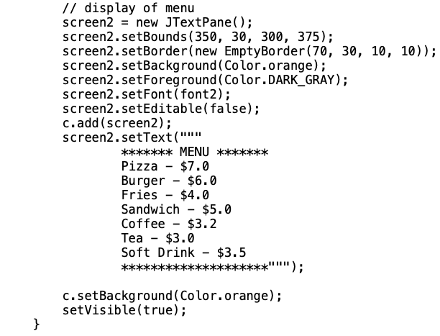

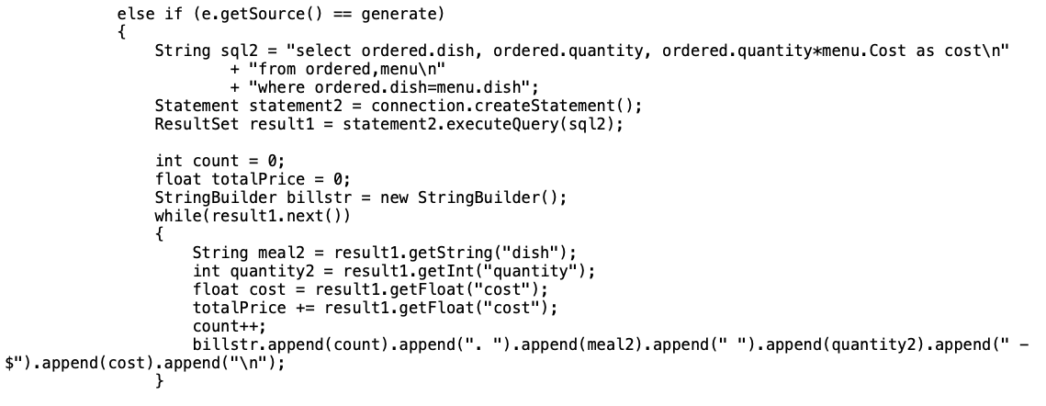

**Output:**

Window 1, for ordering:

Incorrect input gives an error:

Window 2, displaying the bill:

**Script for creating database:**

